

Enquiries: Cynthia Hlope

Tel: 083 568 6031

Fax: (012) 401 6358

Email: cynthia.hlope@gauteng.gov.za

Ref: 11/2/3/1/1/2

DISTRICT MEMORANDUM 513 OF 2016

TO : PRINCIPALS OF PUBLIC PRIMARY, SECONDARY,
INDEPENDENT PRIMARY AND SECONDARY SCHOOLS

FROM : MRS H E KEKANA
DIRECTOR: TSHWANE SOUTH DISTRICT

DATE : 15 NOVEMBER 2016

SUBJECT : ATP 2017, NEW SCRIPTED LESSON PLANS AND SBA TASKS 2017

The purpose of this memo is to invite your school to send all Mathematics Grades 8 and 9 teachers for Mathematics workshop.

The important aspect of the training is to prepare the teachers for the beginning of 2017 looking at:

- Revision Week – revision programme and diagnostic assessments
- ATP 2017 (first term)
- New Scripted lesson plans
- SBA tasks
- Weekly assessments

The details of the planned workshops are as follows:

DATE | VENUE |  | TIME
26 November 2016  (Saturday) | 5903 Kwanadumo Street Extension 2 Nellmapius. From N4 off-ramp Solomon Mahlangu proceed left, first robots off-ramp left, into Pretoria Road proceed straight first robots turn right, first circle turn left Nellmapius Secondary (Full ICT School) is on the right | 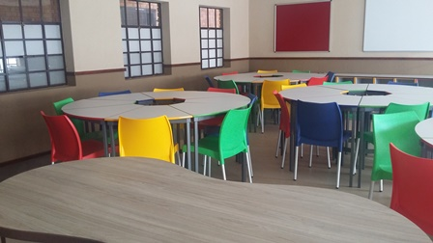 | 8:00 –15:00

The school management teams are requested to encourage their Mathematics teachers to attend the above planned workshops.

Yours faithfully

MRS H.E. KEKANA
DISTRICT DIRECTOR: TSHWANE SOUTH

REPLY SLIP: ATP 2017, NEW SCRIPTED LESSON PLANS AND SBA TASKS 2017 ON 26 NOVEMBER 2016 AT NELLMAPIUS SECONDARY SCHOOL

ATTENTION : Cynthia Hlope Room 6- 39 President
Towers, Pretorius Street, Pretoria
Fax No : (012) 401 6358
Email : cynthia.hlope@gauteng.gov.za

DUE DATE: On or before Wednesday 22 November 2016

School Name | No and Names Of Educators Attending Workshop | Normal/ Veg.
______________ | No:_____  1______________________  2______________________  3_____________________ | ___ Normal  OR  ___ Veg

HOD name and signature:
School Stamp

…………………………………

……….

Principals name and signature:

…………………………………

……….

