TEACHING DIVISION: A FOCUS ON INTER MEDIATE PHASE (Grade 4-6)
Forward
When learners are practicing division they are practicing multiplication facts. Therefore, mastery of multiplication facts and showing the connection between multiplication and division is an important step towards mastery of key elements of division.
It is important to introduce division and multiplication through story problems. These problems should be drawn from what learners experience every day so that learners will make meaning out of them. The problems should draw from continuous quantities such as money, length, time, volume etc.
To solve division problems at the beginning allow children to use their own strategies. You will notice that most of them will use repeated addition and subtraction to solve multiplication and division problems. It is important to develop lessons around two or three problems only but allowing children ample time to practice and explain to each other. Learners should be given amble time to explore, explain and discover connections on their own.
In this workshop learner involvement is very important and the teacher acts as a facilitator. What is important is that learners are given room to explain what they do and why it makes sense. The learners get an opportunity to explain to each other, to the teacher and to the class. Lessons should be interactive. Most successful mathematics lessons are those lessons in which learners share ideas and explain concepts to each other in their own language at their own level.
When multiplication and division are being introduced allow the learners to use models, sets of objects, pictures, drawings and any other physical objects to solve problems. Our learners find it difficult to solve story problems because we start teaching number computations out of contexts in a very abstract way.
All the strategies discussed in this manual are applicable at all grade levels. If learners at grade six levels are struggling with division of 4 digit numbers by 3 digit numbers the teacher can refer to the strategies that were used in previous grades and built up from these basic skills by using simple examples.
The concept of mass creates a context where learners apply their knowledge to multiply or divide numbers when they convert grammes to kilograms or kilograms to grammes. However, for learners to understand the concept of mass before they apply operation in their calculations they should be exposed to how mass is measured. Therefore it is also important to have different types of scales so that learners can measure the different masses of the objects they use in their everyday life. The teacher should take this opportunity to explain other concepts related to mass such as net mass and gross mass. In addition, the concepts should be integrated to other areas of mathematics such as in financial mathematics eg what is paid by George if he buys 3 $\frac{1}{4}$ kg of beef if a kg of beef costs R 53 ,34
Last but not least, you will notice that the strategies that are suggested for this workshop are not the only ones. The teachers are encouraged to explore other strategies as well. However, you should bear in mind that a school is a community of learning, it avails numerous opportunities for exchange of ideas among the educators. Mathematics teachers are encouraged to come together often to discuss problems, share thoughts and generally help each other to make the teaching of mathematics meaningful and interesting.

TABLE OF CONTENTS | PAGE
Forward | 1-2
Icons | 4
Objectives of the presentation | 5
What ideas should guide the teacher when teaching mathematics in general and division in particular? | 5
Key terms in the presentations | 5
What kind of knowledge is required by the teacher to improve understanding of the topic?  Contextual situations for division | 6
Caps requirement for the topic  Calculation strategies for division  What knowledge can assist learners to understand division | 7
Guidelines to the teacher when teaching divisions  Contextual situations for divisions  Strategies for teaching division | 8
Teaching mass  How to measure mass | 14
Measuring mass  Types of scales and definition | 17
Mass measuring story problems | 23
Conclusion | 25

ICONS IN THE MANUAL
 | Text or Reading Material: provides information about the topics objectives that are covered in a manual. Note some units may only have reading information text
 | Introductory Activity: requires you to focus on the content that will be discussed in a unit
 | Self- Assessment: enables you to check your understanding of what you have read and, in some cases, to apply the information presented in the unit to new situations.
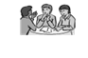 | Practice Activity: encourages you to review and apply what you have learned before taking a unit test.
 | Reflection: asks you to relate what you have learned to your work as a teacher or education officer in your community
 | Summary: highlights or provides an overview of the most important points covered in a unit.
 | Unit Test; concludes each unit
 | Possible Answers: allow you to evaluate your learning by providing sample answers to assessments, activities and the unit test.
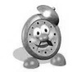 | Time allocated to activities

OBJECTIVES OF THE WORKSHOP

- Identify and apply calculation strategies used for teaching division in intermediate phase.
- Show the connection between prior knowledge and the concept being developed.
- Demonstrate the several methods that can be employed by educators to promote in-depth understanding of the concept.
- Emphasize the importance of scaffolding and feedback when teaching.
- Demonstrate how feedback during the lesson can enhance further teaching and support to learners who struggle
- Provide a platform for debate on how to use problem solving approach when teaching a new concept

WHAT IDEAS SHOULD GUIDE THE TEACHER WHEN TEACHING MATHEMATICS IN GENERAL AND DIVISION IN PARTICULAR
- Learners understand concepts better if taught from known to unknown
- Prior knowledge is important for concept development
- Cues help learners to process information easily
- Local contexts understood by learners help learners to understand concepts better and use concrete materials where possible
- Examples used in a teaching learning situation should draw from learner’s everyday experiences
- Learners should be given the opportunity to interact, share ideas and explain how they get answers

- Provide scaffolding to help learners attain higher levels of mental functioning
- Demonstrations and illustrations should be clear and that emphasis should be given on areas of possible misconceptions through clear questioning and explanations

KEY TERMS IN THE PRESENTATION
1. WHAT IS PRIOR KNOWLEDGE
What learners have done before, what learners already know in relation to the concept
2 WHAT IS SCAFFOLDING
Proving clues, guidelines, demonstrate steps or provide questions
3 WHAT IS A CONTEXT
Situation, experience or example from learners’ experiences that will help to provide meaning to abstractions in a lesson
WHAT KIND OF KNOWLEDGE IS REQUIRED BY THE TEACHER TO IMPROVE UNDERSTANDING OF THE TOPIC?
- Conceptual knowledge
- consists of ideas and relationships that make it possible for a person to what is being taught e.g. prior knowledge.
- Procedural knowledge
-consists of rules and steps used in carrying out routine mathematical tasks and the symbols involved
- General misconceptions made by learners
-addition miscues
-subtraction errors
-multiplication errors
4. How to eradicate them
- Counting in groups
- Use of objects to create sets
- Counting on
- Use of a number line
- Using inverse strategy
- Revising and cross checking with a calculator
- Mark and show all errors
- If you use symbols for feedback and explain them to learners
5. Providing feedback during and after the lesson
- Question learners
- Seek explanation
- Demonstrate
- Give clear illustrations
- Group discussion
- Peer support

DISCUSSION QUESTIONS.
What is conceptual knowledge? Give examples
What is procedural knowledge? Give examples
What prior knowledge should learners have to effectively understand division?
Why is it important for the teacher to have knowledge of misconceptions before teaching division?

CAPS REQUIREMENTS FOR THE TOPIC
GRADE 4: Division of at least 3 digits by 1 digit whole numbers
- Using multiplication and division as inverse operation
GRADE 5: Division of 3 digit whole numbers by 2 digit whole numbers
- Using multiplication and division as inverse operation.
GRADE 6: Division of 3 digit whole numbers by 2 digit whole numbers
- Long division
- Using multiplication and division as inverse operation using a calculator.
WHAT KNOWLEDGE CAN ASSIST LEARNERS TO UNDERSTAND DIVISION
- Learners should understand that; division is about sharing things into a number of equal parts, groups or sets
- Learners should also understand that the whole is measured off in sets of given size
- If repeated addition is used for multiplication, then division can be repeated subtraction
- Estimations can be used to solve division problems

GUIDELINES TO THE TEACHER WHEN TEACHING DIVISION

- learners should experience sharing in groups or pairs -----physically involved in sharing things and creating sets from given numbers
- teachers should use contextual problems that relate to learners’ experiences
- allow learners to solve problems using whatever technique and check through communication discourse how they develop their ideas
- the learners should explain their process to peers to the teacher and to the class

CONTEXTUAL SITUATIONS FOR DIVISION

  - Have real objects for sharing to be used by different groups in the class
  - Play games
  - Use pictures
  - Create real life stories involving sharing
  - Introduce signs in context
  - Show repeated addition and repeated subtraction as inverse processes of multiplication and division
  - Use counting in groups as a process of sharing
  - Use cues to enable learners to master long division

STRATERGIES FOR TEACHING DIVISION
GRADE 4 LEVEL
Strategy 1 Concrete Based Learning
- Use of concrete materials
- Give learners counters up to at least hundred.
- Assign numbers that have several factors eg.12,18,10,54,36
- Learners separate the counters into several subsets.
- Learners should write number sentences to show what they have done,
1. a) Share 15 oranges among3 friends.
b) A class has 45 learners 5 learners share a reading book. How many books are needed for
this class?

c) 20 learners share 5 liters of cold drink equally. How many liters would each one drink?

2 a) 24÷4 b) 16÷4 c) 30÷6 d) 54÷9 e) 60÷5

Strategy 2: Use of Number line
Creating sets from given number lines to solve problems
Demonstrate how to draw a number line.

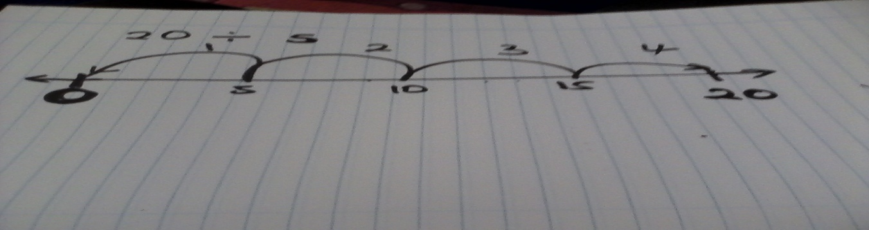
Learners draw number lines to show given numbers.
Given 20 ÷ 5
- Show by using curved lines sets of 5 until one gets to 20
- 64 ÷ 4 b) 120 ÷ 20 c) 45 ÷ 5 d) 50 ÷ 10 e) 500 ÷ 100

Strategy 3 Repeated Subtraction
3. Sharing by repeated subtraction
- Assign learners a number. Remember to put the numbers into context.eg share 45 oranges among five boys. How many does each get?
- How do we solve this problem? Before introducing repeated subtraction allow learners time to debate, explain and even demonstrate to each other how to solve. They should also estimate the answer.
- Ask them to subtract a certain number continuously until they exhaust it
- E.g. 45 ÷ 5 45-5=40
40-5=35
35-5=30
30-5=25
25-5=20
20-5=15
15-5=10
10-5=5
5 – 5=0
How many time has 5 been subtracted. The answer is 9

- 324÷78 b) 12÷6 c) 123÷60 d) 84÷12 c) 108÷9

Strategy 4 Building Sets
- Sharing through building sets
Father shared 12 beads among his three children. How many beads did each one get?
- At the beginning allow learners to draw diagrams
- Let them physically draw the 24 beads as shown below
- Let them share the beads by drawing and showing the sets

1st child 2nd child 3rd child

The meaning of the above can be shown in different ways. The responses below should come from the learner to reflect how the learner has interpreted the problem. Introduce the different forms of division and the sings

- 12 ÷ 3 = 4 b) $\frac{12}{3}$ = 4 c)

GRADE 5 LEVEL
Strategy 5 Counting In Sets 0f Friendly Numbers
378 marbles were shared among John, Peter and Mary. How many marbles did each one of them get? Show all your working.
- Share 100 first
- then the 20s
- then the 6
- Add to get the answer

 | John | Peter | Mary | = 378
STEP 1 | 100 | 100 | 100 | -300
STEP 1 | 20 | 20 | 20 | 78  = -60
 | 6 | 6 | 6 | 18  -18
ADD | 126 |  |  | 00

Strategy 6 Near Facts
318 ÷ 7
7 times what number is near 318
- 10 x7 = 70 too small
- 100x 7 = 700 too big
Then multiples of 10
- 7x50 = 350 too big
- 7x40= 280
318 - 280=38
- 7x5=35 remainder 3
Answer is 40 +5=45 remainder 3
Use of common abbreviations that make meaning to learners
3 378

Use the abbreviation D M S B (Dad, Mother, Sister, Brother ) mathematically this means Divide, Multiply, Subtract, and Bring down

3 378
- 300
78
- 60
18
- 18
00

Ask leading questions
- How many sets of 3 do we have in 3 (hundreds) = 100 and then multiply 100 x 3 = 300
- Is there a remainder – then subtract.
- How many sets of 3 do we have in 7 tens (70) – count in threes.
- How many sets of 3 do we have in 18?
Count in threes
- Is there any remainder
Try the following

a ) 32 456 b ) 67 5678 c ) 23 789567

d) 25 987 e) 67 786456 f ) 65 89706

GRADE 6 LEVEL
Strategy 8 the Breakdown
378 ÷ 3 = 300 + 60 + 18
= (300 ÷ 3) + (60 ÷ 3)
+ (18 ÷ 3)
Breakdown the number into the multiples of 3
= 100 + 20 + 6
= 126

Strategy 7: Long Division Working from Multiples and Factors

Step 1: Work out at least 7 multiples of 23 on a separate paper.
23 5431 23 x 2 = 46
23 x 3 = 69
23 x 4 = 92
23 x 5 = 115
23 x 6 = 138

DMSB (Dad, Mother, Sister, Brother )
236 r 3 Step 2: 23 into 54. Check for the multiple closest to 54.
23 5431 How many times do we multiply it by 46 (twice) 2 times
- 4 6
8 3 Step 3 subtract the 46
- 6 9
Step 4: Bring down 3 as indicated by an arrow.
1 4 1
- 1 3 8 Step 5: Which multiple is closer to 83 its 69.
Remainder 3 The how many times do we multiply 23 to get 69.
Multiply by 3 and then subtract from 83.

Step 6: Bring down 1 and check for a multiple of 23
closest to 141 its 138.

Applications
1.84 marbles were given 17 learners. How many marbles did each get?
2. There were 25 bags of cement. The man paid 3 782 for them. How much was each costing?
3. Susan bought a bed. She paid 118 rand in 10 months instead of 15 months. The shop owner reduced the price of the bed by 118 rand. How much did she pay?
4. A farmer planted 23 plants in 16 rows. 12 plants were added and 8 died. How many plants survived?

TEACHING MASS: A FOCUS ON INTER MEDIATE PHASE (Grade 4-6)

Weight or Mass?
Q: Aren't "weight" and "mass" the same?
A: Not really.
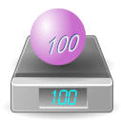 |  | An object has mass (say 100 kg).  This makes it heavy enough to show a weight of "100 kg".

Gravity causes Weight
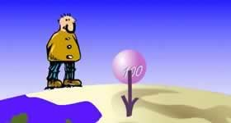 | An objects weight is how hard gravity is pulling on it.  We think the weight is the same everywhere ... because we all live on the surface of the planet Earth!

But in orbit it would not push on the scales at all.  The scales would show 0 kg ... but the mass is still 100 kg ! |  | 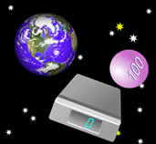
An object's mass doesn't change (unless you remove some!), but its weight can change.

So Why Do People Say Weight instead of Mass?
People often use "weight" to mean "mass", and vice versa.
Because gravity is pretty much the same everywhere on Earth, we don't notice a difference.
But remember... they do not mean the same thing, and they can have different measurements.
Here are some conditions where the Weight might change:
- in space (can be weightless!)
- on the moon (a 100 kg mass would weigh 16.6 kg)
- you can even get very slight differences in weight in different locations on earth!

Weight is a Force
So ... if weight and mass are different, why are they both in kilograms?
Well, weight should not really be in kilograms!
We use "kilogram" so far because that is what you would see on a pair of scales, but it is technically wrong to talk about weight in kilograms ...
WHAT IS THE BASIC DIFFERENCE BETWEEN TEACHNG MAS IN GR 4, GR 5 AND GR 6?

Mass poses particular problems for some students because they confuse it with volume, size or quantity. A common misconception is that the larger the size of an object, the greater the mass. This occurs when the judgment made is based on sight (a transfer from learning about length) rather than on feel. For example, students may think that a tennis ball is heavier than a golf ball because it is larger. In relation to quantity, students may think that three foam balls are heavier than a soccer ball because there are more of them.
Mass is a more complex measure for children than length in that it cannot be appreciated visually and because direct comparison of the mass of objects is imprecise unless a balance is used.

HOW KIDS LEARN TO MEASURE MASS
However, early understanding of mass can be acquired through holding items and describing them as heavy or light. Subsequently, children can use direct comparison methods by holding two items, one in each hand leading to comparison of the mass of two objects using a beam balance. This allows the teacher to introduce comparative language: heavier, lighter, heaviest and lightest. Collections of more than two objects can then be compared.
When introducing units for mass, a wide range of non-uniform, non-standard (arbitrary) units should be used (e.g. pebbles, shells, tennis balls etc.). Typical uniform non-standard units might include marbles, cubes, coins or counters. The final stage in introducing units is the introduction of the standard units for mass (grams and kilograms). Work can be done on finding items which are lighter or heavier than a given mass. In the later stage children can be expected to make conversions between metric units and to know conversions of mass (g, kg and t)

AT GLANCE
- Kids learn about measurement through watching their parents.
- Kids initially develop an understanding of measurement through comparing objects.
- Talk about how many cups or teaspoons of each ingredient are used in a recipe when they are cooking together with mother.
- Have child help parents weigh items when grocery shopping.
- Talk about how much child weighed when they were born.
Counting out how many teaspoons of sugar are needed for a recipe are fun ways for kids to start understanding mass. Kids' early experiences with measurement are often based on watching their parents. Seeing mum or dad measure and pour ingredients for a recipe or weigh items at the fruit shop will often become part of their play.

WHAT PARENTS CAN DO AT HOME
- Talk about how many cups or teaspoons of each ingredient are used in a recipe when you are cooking together.
- Talk about how much you can hold in your hand. Compare how many marbles or small rocks you can hold to the number your child is able to hold.
- ‘Hefting' is the balancing of an object in each hand and deciding which is the heavier or lighter. This is a good way for children to compare the weight of objects.
- Show your child how you use kitchen scales to measure ingredients.
- Have your child weigh themselves on bathroom scales. Weigh other family members and family pets.
- Talk about how much your child weighed when they were born.
- Show where the weight of goods is recorded on food packets.
- Have your child help you weigh items when grocery shopping.

Let’s not forget:
A gram is about:
- a quarter of a teaspoon of sugar
- a cubic centimeter of water
- a paperclip
- a pen cap
- a pinch of salt
- a piece of gum
A kilogram is about:
- the mass of a liter bottle of water
- 7 apples
- two loaves of bread
A tone is about:
- the weight of a small car

MEASURING MASS OR WEIGHT

- The scientific word for how much an object weighs on a scale is “mass”. In this book we will use the words “weight” and “mass” interchangeably, because both are used in everyday language. For example “I weigh 60 kg” or “the car's mass is 1 tone”.
- In many contexts, we use scales to measure weight or mass. Different types of scales are used to measure different sizes of objects. Some examples are given in the table below.
TYPES OF SCALES AND DEFINITION
Definition 1: Analogue scale
- A scale that has no electronic devices attached to it, (e.g. LCD screens)
Definition 2: Digital scale
- A scale that has electronic devices on it like digital and LCD screens.
Definition 3: Calibration
- This is process by which a scale is set in order to take accurate readings.
- Most analogue scales can become inaccurate when they are moved around, because they have moving parts inside that can shift if the scale is bumped or dropped. Therefore, before we use an analogue scale we have to adjust it to make sure that it gives the most accurate readings possible. This process of adjusting the scales again is called re-calibration.
- Digital scales are calibrated (adjusted for accuracy) in the factory when they are made and do not become inaccurate when they are moved. Other, larger scales like a weighbridge will be calibrated on-site (usually by a professional engineer or technician).

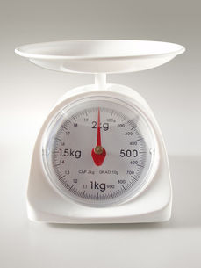
Kitchen scales can be used to measure small quantities of food usually up to 2 or 3 kg. The scale on the left can measure weight between 0 and 2 kg in weight. The units are divided into kilograms and grams.

Bathroom scales can be analogue or digital (like the scale on the left). They are used to measure a person's weight, and can measure weight from 0 to 150 kg. Bathroom scales usually show units in kilograms and grams - e.g. 63,6 kg.
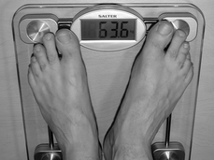

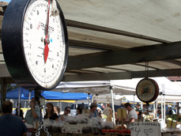
Scales for measuring larger quantities of food (like vegetables or fruit) are sometimes seen in shops or at markets. The scale on the left can measure weight from 0 to 10 kg.

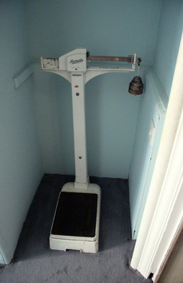
Clinics and doctors' practices often use larger analogue scales to measure a person's weight. These can also measure weight between 0 and 150 kg.

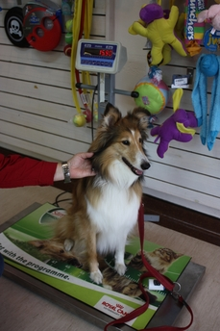
Flat electronic scales, called platform scales, can be used to measure bulky objects like suitcases (at the airport) or dogs (at the vet).

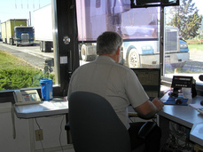
Weighbridges are used to measure very large objects like trucks. The truck drives onto a special strip of road that is connected to a digital scale. The scale operator (shown in the picture on the left) then reads off the truck's weight in tonnes.

Which measurement can we use for the following (kilograms or grams)
THE VARIABLE | ANSWERS

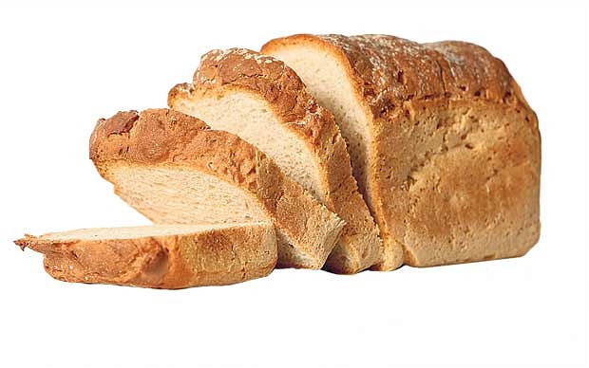



A tractor

Amount of salt to add in the meat

6 teaspoons of powder milk

Converting kilograms into grams:

There are 1,000 grams in one kilogram. This means that converting grams to kilograms is easy: just multiply the number of grams by 1,000

e.g. 2kg = 2 $×$ 1000 = 2000g, 37kg = 37 $×$ 1000 = 3 700g,

Complete the following:
    - 3kg = ____________ = __________

    - 14kg = ____________ =__________

    - 20kg = ____________ = __________

    - 100kg = ____________ = __________

    - 103kg = ____________ = __________

Converting kilograms into grams:

There are 1,000 grams in one kilogram. This means that converting kilograms to grams is easy: just divide the number of grams by 1,000

e.g. 3kg = $\frac{3}{1000}=0.003g$; 50kg = $\frac{50}{1000}=0.05g$

complete the following:
    - 3000g = ____________ = __________

    - 250g = ____________ =__________

    - 2g = ____________ = __________

    - 125g = ____________ = __________

    - 14g = ____________ = __________

Example of measuring weight:
Study the following pictures of food on a scale and answer the questions that follow:

Question 1
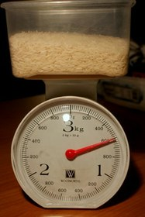
- How much does this rice weigh in grams?
- Convert the answer in “a” above to kilograms.
Question 2:

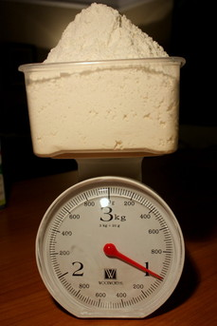

How much is this flour measured in kg? Convert this in grams.

“Mass Measurement Story Problem”
Choose the proper operation to solve the problems, then write your answer on the line provided.
1. Kanyi’s body weight is 22 kilograms, while Kiara’s body weight is 3 kilograms heavier than Kanyi. How heavy is Kiara?
To solve this problem, I need to do (subtraction / addition).
………………………………………………………………………
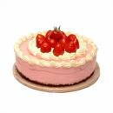
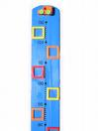
2. Alex’s mom wants to make a cake. She bought 585 grams of flour, 250 grams of eggs, and 150 grams of sugar. What is the total weight of the things that Alex’s mom bought?
To solve this problem, I need to do (subtraction / addition).
…...………………………………………………………………….

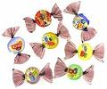
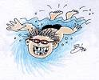
- Lindiwe had 1 kilogram of candy. After she gave some to Beaty, she still has 290 grams
left. How heavy was the candy that Lindiwe gave to Beauty?
To solve this problem, I need to do (subtraction / addition).
4. a) If I was weighing out 2024 grams what would it be rounded up in kilograms?

4. a) If I was weighing out 2024 grams what would it be rounded up in kilograms?

b) Now if I decided that it wasn’t enough, and I added another 1000 grams, what would it be
in kilograms now?

- Now I take 43 grams off the measurement, what would it be in kilograms now?

d) What would I need to make that 10kg?

5. For my recipe I need 100 grams of flour, 80 grams of sugar, 400 grams of water, now write this down in kilogram form, e.g. 0.2kg

6. A box of Smarties weighs 425g and has yellow, green, pink, purple and red sweets. In each pack each colour weighs:
Yellow = 150g Green = 70g Pink = 85g Purple = 60g
How much do the red sweets weigh in each box?

7. Complete the table:

kilograms (kg) | Kg and g | grams (g)
1.25kg | 1kg 250g | 1250g
1.5kg
 | 1kg 900g
0.7kg
 | 1kg 750g
0.24kg
 |  | 380g
 |  | 2040g
Question 3:
A chef is preparing a meal that needs 3,75 kg of rice and 1,5 kg of beef. The recipe will feed 8 people.
- Rice is sold in packets of 2 kg. How many packets will he need for this meal?
- Suppose it costs R 31,50 per 2 kg pack. Calculate the total cost of rice he will need.
- If beef costs R 41,75 per kg, calculate the total cost of beef needed for this meal.
- Calculate the total cost of preparing the meal. (Assume that all the other ingredients are available for free).
Net Mass, Gross Mass
- The mass of a loaded lorry is 15 tones. If the mass of the empty lorry is 2,500kg. What is the net mass?
- If the net mass of the load is 15,678 tones and the empty lorry is 2, 500 tones. What is the mass of the loaded lorry?

CONCLUSION
Questions given to learners during lessons should cut across the four cognitive levels shown in the caps document. The levels are informed by bloom’s taxonomy which we would look at in our future workshops
Learners could understand measurement much better if you use games. You can use a following link as additional activities:
Woodlands Measures Skills - Woodlands Junior School Kent (reading measures, weight it up)

