TEACHING LENGTH: A FOCUS ON INTERMEDIATE PHASE (Grade 4-6)
Forward
Although measurement is allocated only 15% in the CAPS document it is not an easy topic for learners to understand. Research studies carried out to date show that most learners are weaker in measurement than any other topic in the curriculum (Thompson and Preston, 2004). The 201 Sasolburg to Johannesburg 4 ANA diagnostic report also indicated that learners performed poorly on questions based on measurement hence the need for this workshop on length.
The main cause for poor performance in measurement is based mainly on how the topic is taught. For learners to understand this concept the teachers should start by focusing more on hands on experiences that are practical in nature.
Development and understanding of this concept should follow the following sequence. Firstly, learners should compare units of length to units of length. Introduce the words such as shorter, longer, taller and higher the learners can compare a ruler to a pencil, a straw to a meter rule, a rope to a tape measure, the height of the teachers and learners etc.
Secondly, the learners should understand the units of measurement for a particular attribute and how the units are used to produce measurement. For length we use both standard and informal units such as feet. Introduce useful vocabulary as you go the topic “length”, “width” and “height”. Learners should progress from nonstandard units to standard units. Base your activities on estimation and the measuring to check how “far” or “near” the answer are the learners.
The third goal is to enable learners to understand the devices used to measure. The learners are familiar with the ruler then start with the ruler. How long is the crayon, side of a book, the length of the table and other models in the classroom? Learners should be given an activity to make and use their own rulers and move to actual rulers’. The other activities such as measuring in meters and conversions will follow when learners have a full grasp of measures and in the primary school emphasis should be on metric units.

Table of Contents
TEACHING LENGTH: A FOCUS ON INTERMEDIATE PHASE (Grade 4-6) 1
THE ICONS 3
KEY TERMS THE TEACHERS NEED TO KNOW 4
IMPERIAL UNITS: 4
METRIC SYSTEM: 4
5
WHAT KIND OF KNOWLEDGE IS REQUIRED BY THE TEACHER TO IMPROVE UNDERSTANDING OF THE LENGTH? 5
CAPS REQUIREMENTS FOR THE TOPIC 7
HOW CAN LEARNERS UNDERSTAND LENGTH? PRACTICAL APPLICATION 8
USING NON STANDARD UNITS 8
Worksheet to check the application 9
WHAT TO OBSERVE AND TO EMPHASIZE WHEN DOING THE TASK 11
MAKING AND USING RULERS 11
PRACTICAL WORK INVOLVING METRES 14
PRACTICAL WORK INVOLVING TRUNDLE WHEEL 14
PRACTICAL WORK INVOLVING STRING 14
PROBLEM SOLVING 14
DRAWING LINES OF DIFFERENT LENGTH 15
RELATIONSHIP BETWEEN THE UNITS OF LENGTH 15
INTRODUCTION TO THE DECIMAL NOTATION 17
WRITE THE FOLLOWING USING THE DECIMAL NOTATION. 17
FRACTIONS AND LENGTH 20
APPLICATIONS 20
CONSOLIDATION 22
CONVERTING CENTIMETRES TO MILLIMETRES 22
CONVERTING MILLIMETRES TO METRES 22
MILLIMETRES TO CENTIMETRES TO METRES TO KILOMETRES 22
CONCLUSION 24

THE ICONS
 | Text or Reading Material: provides information about the topics objectives that are covered in a manual. Note some units may only have reading information text
 | Introductory Activity: requires you to focus on the content that will be discussed in a unit
 | Self- Assessment: enables you to check your understanding of what you have read and, in some cases, to apply the information presented in the unit to new situations.
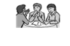 | Practice Activity: encourages you to review and apply what you have learned before taking a unit test.
 | Reflection: asks you to relate what you have learned to your work as a teacher or education officer in your community
 | Summary: highlights or provides an overview of the most important points covered in a unit.
 | Unit Test; concludes each unit
 | Possible Answers: allow you to evaluate your learning by providing sample answers to assessments, activities and the unit test.
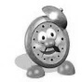 | Time allocated to activities

KEY TERMS THE TEACHERS NEED TO KNOW

IMPERIAL UNITS:
Used in the United Kingdom e.g. Inches; Feet; Yards; Ounces; Pints; Mile; Pound; Gallon etc. some of your learners might think these are non-standard units, so the teachers will have to explain.

METRIC SYSTEM:
Units based on Metre (meter in USA) are derived from the Greek word “metron” meaning to measure.
The symbol “$m$” after a number means the number is measured in metres
e.g. 10$m$ means 10 metres.
Latin prefixes are used to express fractions of a metre
e.g. milli means $\frac{1}{1000}$ thus 1 $mm$ = $\frac{1}{1000}$ metre
centi means $\frac{1}{100}$ thus 1 cm = $\frac{1}{100}$ metre
1metre ($1m$) = 100 centimetres ($cm$)
Since 1$m$ = 1000 $mm$ and 1m =100$cm$ then 10$mm$ = 1$cm$
1$km$ written as kilometer = 1000 metres
NB These Greek prefixes are also used with other metric units
The information above is the basis for conversion because to convert from one unit to smaller unit you multiply by multiples of 10 and to convert to a bigger unit you divide by10,100 and1000 depending on the unit’s measure.

WHAT KIND OF KNOWLEDGE IS REQUIRED BY THE TEACHER TO IMPROVE UNDERSTANDING OF THE LENGTH?

- Conceptual knowledge
consists of ideas and relationships that make it possible for a person to ASSIMILATE AND ACCOMMODATE new concepts. These ideas can be built through working with - Nonstandard units to begin measuring length e.g. footprints, ropes, straws, paperclips, toothpicks, chain links etc.
Using standard units e.g. $cm$, $m$, $km$, understanding the ideas can be built through working with rulers, metre rule , tape measure, Surveyor`s wheel
- Procedural knowledge
consists of rules and steps followed when working out answers to routine mathematical tasks including conversions.

- Appropriate language
- The desk is about 5 metres long
- Shorter, longer, higher than

- Knowledge of the role of estimation
- Estimation develops familiarity with the unit
- Provides intrinsic motivation to measuring activities
- Promotes reasoning

- Making and using measuring instruments
- Understanding devices we use to measure different distances(lengths)
- Understanding how each one of the devices works

DISCUSSION QUESTIONS
Why is it important to teach learners to estimate?
_____________________________________________________________________
_____________________________________________________________________
Why is it important for learners to compare lengths of different objects before they measure them practically?
______________________________________________________________________
______________________________________________________________________
Why is it important for learners to make measuring instruments before they use actual ones?
______________________________________________________________________
______________________________________________________________________
When is it appropriate to introduce standard units of measuring length?
______________________________________________________________________
______________________________________________________________________
What misconceptions have you identified in teaching length using your approach?
______________________________________________________________________
______________________________________________________________________

CAPS REQUIREMENTS FOR THE TOPIC
^{TOPIC} | ^{Grade 4} | ^{Grade 5} | ^{Grade 6}
^{Length} | Practical measuring of 2-D shapes and 3- D objects by  ^{•estimation}  ^{•measuring}  ^{•recording}  ^{•comparing and ordering}  ^{Measuring instruments}  Rulers , metre sticks, tape measures ,trundle wheels  ^{Units}  Millimetres(mm),centimetres(cm), metres(m),kilometres(km)  Calculations and problem solving involving length  •solve problems in contexts involving length  •Conversions include converting between •  -millimetres(mm)and centimetres(cm)  - centimetres(cm) and metres(m)  ^{-metres(m) and kilometres(km)}  •Conversions limited to whole numbers and common fractions | Practical measuring of 2-D shapes and 3- D objects by  ^{•estimation}  ^{•measuring}  ^{•recording}  ^{•comparing and ordering}  ^{Measuring instruments}  Rulers , metre sticks, tape measures ,trundle wheels  ^{Units}  Millimetres(mm),centimetres(cm), metres(m),kilometres(km)  Calculations and problem solving involving length  •solve problems in contexts involving length  •Conversions include converting between any of the following units:  ^{-millimetres(mm)}  ^{- centimetres(cm)}  ^{-metres(m)}  ^{-kilometres(km)}  •Conversions limited to whole numbers and common fractions | Practical measuring of 2-D shapes and 3- D objects by  ^{•estimation}  ^{•measuring}  ^{•recording}  ^{•comparing and ordering}  ^{Measuring instruments}  Rulers , metre sticks, tape measures ,trundle wheels  ^{Units}  Millimetres(mm),centimetres(cm), metres(m),kilometres(km)  Calculations and problem solving involving length  •solve problems in contexts involving length  •Conversions include converting between any of the following units:  ^{-millimetres(mm)}  ^{- centimetres(cm)}  ^{-metres(m)}  ^{- kilometres(km)}  •Conversions limited to whole numbers and common fractions to 2 decimal places

HOW CAN LEARNERS UNDERSTAND LENGTH? PRACTICAL APPLICATION
1. Give learners objects to compare.
After the leaners have practically used taller, longer, shorter, same and higher
Putting thing things in order of length or height e g. Learners in a group
2. Give them a worksheet where they will describe length of objects shown
- Height of a mountain and a tree
- Height of your teacher and you
- A rope and a straw
- Height of a shelf and a chair
- Length of a book and a file
- Who is the tallest or shortest in the group?

USING NON STANDARD UNITS
- Divide your learners into pairs or groups of three
Give them straws, paper clips, tooth picks, ropes
Assign them tasks to measure and record their measurements
- length of the table
- width of a table
- height of a chair
- trunk of a tree
- circumference of a bucket

- Give learners two objects of different lengths, heights or circumference.
Ask how much longer or shorter is the first object compared to the second

Worksheet to check the application
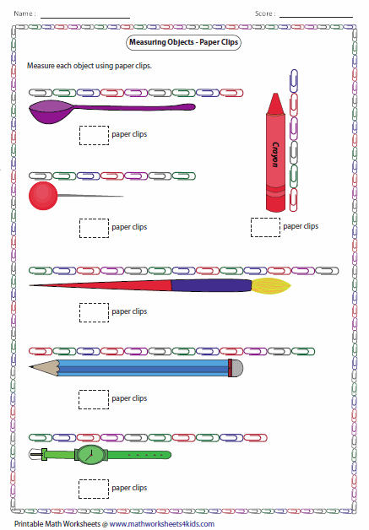

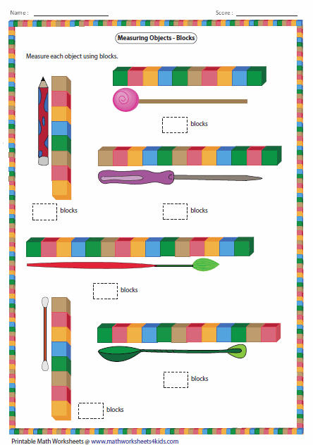

WHAT TO OBSERVE AND TO EMPHASIZE WHEN DOING THE TASK

- Observe if the learners understand that the units they use should be the same size
- Ask learners to draw a line and mark off distance of prescribed units checking if they are no overlaps or gaps left between the units
- Ask to verify if learners can mentally sub divide any object into different sizes by measuring strings of three units or four units
- Can learners visualize that a string of six paper clips is three times shorter than that of eighteen or that half of a six clip string is three clips long?

MAKING AND USING RULERS
This exercise is meant to enable learners to understand rulers and the subdivisions of millimetres. They are to make rulers of actual units. This is a problem based experience for learners
- Bring “cut strips” and give them to learners so that they can lay them end to end and mark the centimetres ($cm$) and millimetres ($mm$)
- Learners should now measure lengths of objects longer than their rulers
- Where possible give learners a broken ruler with the first numbers missing and see if they can measure lengths of objects correctly
- Let them also measure objects shorter than their rulers and see what they get
- Visit maths drill.com for more activities for your class

Worksheets to check the application

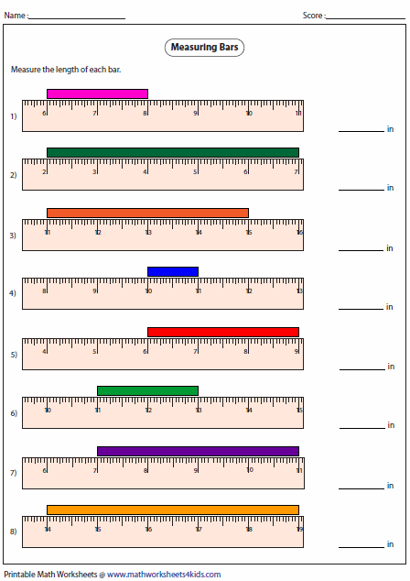

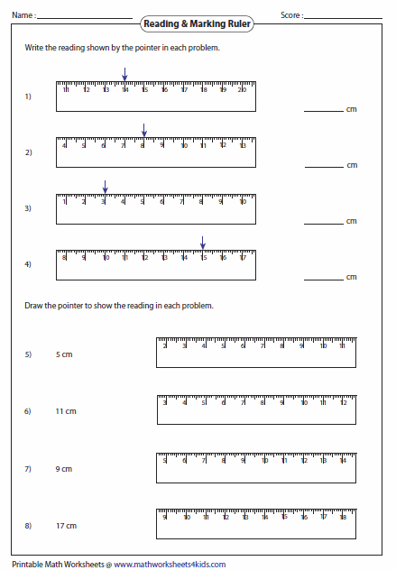

PRACTICAL WORK INVOLVING METRES
Group learners and assign them tasks to measure items like:
- Tables in the classrooms or teacher’s table
- width and length of the classroom
- distance from the principal’s office to the gate
- width of the road (within the school yard)
- length of a car bus or lorry

PRACTICAL WORK INVOLVING TRUNDLE WHEEL
- Measure length, width and perimeter of the school field
- Measure length, width and perimeter of the school buildings
- Distance from the principal’s office to the gate
- Distance from your classroom to the principal’s office to the gate
- Distance gate to your classroom

PRACTICAL WORK INVOLVING STRING
- Tree trunks
- Wheels
- Drums
- Circumference of your waist
- Circumference of a bucket

PROBLEM SOLVING
There is a need for integration at this stage where you check your learners understanding of the relationship between half and $cm$
How many ½ (half) cm are in?
- 1$cm$
________________________________________
- 1 $\frac{1}{2} cm$
_________________________________________
- 9 $\frac{1}{2} cm$
_________________________________________
- 11$cm$
_________________________________________
- 5$cm$

_________________________________________

DRAWING LINES OF DIFFERENT LENGTH
Draw line segments of the following length
- 4$cm$

- 7$\frac{1}{2} cm$

- 10 $cm$

- 9$\frac{1}{2}$ $cm$

- 11$cm$

RELATIONSHIP BETWEEN THE UNITS OF LENGTH
Separating $mm$ and $cm$ and $m$ and $km$
Use your ruler, metre ruler to find answers of the questions below:
- If 1$cm$ =10$mm$ then 12$mm$ = 1cm and 2$mm$
- 13$mm$ = ________________________

- 34$mm$ = ________________________

- 156$mm$ = _______________________

- 78$mm$ = ________________________

- 17$mm$ = ________________________
Discuss with your learners a quicker way of getting the answer

- If 2$cm$ and 1$mm$ = 21$mm$ find how many $mm$ make the following

  - 2$cm$ and 3$mm$ = ____________

  - 5$cm$ and 6$mm$ = ____________

  - 67$cm$ and 8$mm$ = ____________

  - 6$cm$ and 8$mm$ = ____________

  - 10$cm$ and 5$mm$ = ____________
Discuss with your learners a faster way of getting the answer
- Calculate the number of cm in given m and cm
  - 3$m$ and 45$cm$ = ____________

  - 15$m$ and 6$cm$ = ____________

  - 10$m$ and 09$cm$ = ___________

  - 8$m$ and 19$cm$ = ___________

  - 3$m$ and 42 $cm$ = ____________

- Calculate the number of metres ($m$) and centimetres ($cm$) in the following:
- 589$cm$
______________________________________
- 675$cm$
______________________________________
- 1050$cm$
______________________________________
- 1234$cm$
______________________________________
- 678$cm$
______________________________________

- Convert the number given in $km$ and $cm$ to $m$:
- 3$km$ and 45$m$ = _______________________

- 15$km$ and 6$m$ = _______________________

- 10$km$ and 09$m$ = ______________________

- 8$km$ and 19$m$ = ________________________

- 3$km$ and 42$m$ = _______________________
- Calculate the number of km and $m$ in
- 2589$m$ = ____________________

- 23 675$m$ = __________________

- 1050$m$ = ____________________

- 1234$m$ = ____________________

- 678$m$ = ____________________

INTRODUCTION TO THE DECIMAL NOTATION
Units of length in the metric system.
1$cm$ =10$mm$ 1$m$ = 100$cm$ 1$km$ = 1000$m$
If 1$cm$ and 2$mm$ can be written as 1,2$cm$

1$m$ and 56$cm$ as 1,56$m$

23$km$ and 456$m$ as 23,456$km$

WRITE THE FOLLOWING USING THE DECIMAL NOTATION.
Discuss with the learners how to get the answer and what they notice on the answer
Convert to cm using the decimal notation
- 13$mm$ = _________________________

- 34$mm$ = ________________________

- 156$mm$ = ________________________

- 78$mm$ = _________________________

- 17$mm$ = _________________________

- Write in $cm$ using the decimal notation
- 2$cm$ and 3$mm$ = ______________________

- 5$cm$ and 6$mm$ = ______________________

- 67$cm$ and 8$mm$ = ______________________

- 6$cm$ and 8$mm$ = ______________________

- 10$cm$ and 5$mm$ = ______________________

- Write in $m$ using the decimal notation
- 3$m$ and 45$cm$ = ______________________

- 15$m$ and 6$cm$ = ______________________

- 10$m$ and 09$cm$ = ______________________

- 8$m$ and 19$cm$ = ______________________

- 3$m$ and 42$cm$ = ______________________

- Write in $m$ using decimal notation
- 589$cm$ = ______________________

- 675$cm$ = ______________________

- 1050$cm$ = ______________________

- 1234$cm$ = ______________________

- 678$cm$ = ______________________

- Write in $km$ using the decimal notation
- 3$km$ and 45$m$ = ______________________

- 15$km$ and 6$m$ = ______________________

- 10$km$ and 09$m$ = ______________________

- 8$km$ and 19$m$ = ______________________

- 3$km$ and 42$m$ = ______________________

Write in $km$ using decimal notation
- 589 $m$ = ______________________

- 675 $m$ = ______________________

- 1050 $m$ = ______________________

- 1234 $m$ = ______________________

- 678 $m$ = ______________________
Discuss how the learners will get the answer. Give the learners an opportunity to explain to the whole class
The learners should discover that when changing to a bigger unit they divide and multiply when changing to a smaller unit

FRACTIONS AND LENGTH
Calculate.
a)$\frac{3}{4}$ of a $m$ = ______ $cm$
b) $\frac{2}{5}$ $m$ = ______$cm$
c) 4$\frac{2}{5}$ km= _______ $m$
d) 1 $\frac{1}{2}$ $m$ =_______ $cm$

APPLICATIONS

5,3$cm$

10,2$cm$
- How much longer is the length than the width?

_____________________________________________________________
- What is the distance around the shape in $m$?

______________________________________________________________
- Palesa used 3 pieces of rope to make a hutch. One piece was 45 $cm$ another 1,75$m$ long. The third one was $\frac{3}{4} m$. How many metres of wire did he use altogether?
______________________________________________________________
- 31,2$m$ was cut into four pieces how long was each piece?

- The picture below shows a taxi route from Sasolburg to Pretoria. The distances are shown in kilometres in the diagram below. Answer the questions that follow:
Sasolburg

189km sebokeng Pretoria
15,7km 25km 60km 45,9km
Vereeneging 80km Johannesburg Springs
46,7km
94km Lenassia

J

  - How many kilometres is it from:
- Sasolburg to Pretoria via Sebokeng?

___________________________________________________
- Sasolburg to Pretoria via Vereeniging and Johannesburg to Pretoria?
_____________________________________________________
- Sasolburg to Vereeniging?
______________________________________________________
- Sasolburg to Johannesburg via Vereeniging?
______________________________________________________
- How long is the shortest distance from Sasolburg to Johannesburg?
_______________________________________________________
  - How much further did Palesa travel from Sasolburg via Vereeniging Lenassia, Johannesburg to Pretoria than from Sasolburg via Sebokeng to Pretoria?

_______________________________________________________

_______________________________________________________

CONSOLIDATION
The use of abstract can now be used to solve conversion of units.
This diagram may be of use as a summary to show the relationship between the length units as follows:
1centimetre = 10 millimetres; 1 metre = 100 centimetres; 1 kilometre = 1 000 metres

CONVERTING CENTIMETRES TO MILLIMETRES
Firstly refer to the reference table: 1$cm$ =10$mm$, then check the units to be converted. For example, 5$cm$ = 50 $mm$ multiply 5 by 10 85$cm$ = 850$mm$
In this regard it means the centimetres are multiplied by 10.
Converting 850$mm$ to $cm$, it means you divide by 10 .
850$mm$ = 85$cm$; 50$mm$ = 5$cm$

CONVERTING MILLIMETRES TO METRES
Reference: 1$m$ = 100$cm$ = 1 000$mm$
For example, convert 20$mm$ to metres.
Participants need to be aware that they need to change the millimetres to centimetres and then to metres as follows:
20$mm$ ÷ 10 = 2$cm$ then 2$cm$ ÷100 = 0,02$m$.
The same applies when you convert 20$mm$ to $km$, use the reference table.

MILLIMETRES TO CENTIMETRES TO METRES TO KILOMETRES
20$mm$ = 20÷ 10 $cm$ = 2$cm$ ÷ 100$m$ = 0,02$m$ = 0,02 ÷ 1 000$km$ = 0,00002$km$.
When converting $km$ to $m$ to $cm$ to $mm$
Reference: 1$km$ = 1 000$m$ = 1 000 x 100 $cm$ = 1 000 x 100 x 10 $mm$
For example, convert 3 $km$ to $mm$:
First change to metres; 3$km$ = 3 x 1 000$m$ = 3 000$m$
Then, convert 3 000m to $cm$ = 3 000 x 100 $cm$ = 300 000$cm$

Finally, convert 300 000$cm$ to $mm$ = 300 000 x 10 = 3 000 000$mm$
x 1 000 x 100 x 10
$$km$$
$$m$$
$$cm$$
$mm$ m

÷ 1 000 ÷ 100 ÷ 10

In a nutshell, converting $km$ to $mm$, multiply and converting mm to km divide.

CONCLUSION

All approaches to be used should begin from simple to complex. The strategies used at grade four or five level can also be used in grade 7 if learners experience problems. Give learners not only an opportunity to work out problems using their own methods but further question and probe them to explain how they get their answers. By listening to the explanations they give and looking at their demonstrations you will be able to pick on misconceptions and errors that must be corrected. Ensure that you integrate the topics so that learners can see the relationships and would apply what they know to understand the new concept being taught. It is also important to use learners’ experiences so they can make connections through seeing the relevance of the concept in solving real life problems.

